**Part 1: Simulink State-Flow Design Document**

**Introduction to the task:**

The project goal at hand is to create a virtual pacemaker that can sense and pace signals from the heart, and output the corresponding heart data to the end user. This task is implemented using the K64F board, as well as the virtual heart, and pacemaker shield. In order to achieve this, the project is split into 3 parts. Part 1 focuses on setting up a stateflow in Matlab Simulink in order to monitor and control data within different pacing and sensing modes of the heart. Since the project is still in the early stages, only the AOO, VOO, AAI, and VVI modes are being implemented.

Environment variables

|  |  |
| --- | --- |
| **Controlled variable (aka programmable parameter)** | **Value** |
| Mode | AOO, VOO, AAI, and VVI |
| Lower Rate Limit |  |
| Upper Rate Limit |  |
| Atrial amplitude |  |
| Ventricular amplitude |  |
| Atrial pulse width |  |
| Ventricular pulse width |  |
| Atrial sensitivity |  |
| Ventricular sensitivity |  |
| VRP |  |
| ARP |  |
| PVARP |  |
| Hysteresis |  |
| Rate Smoothing |  |

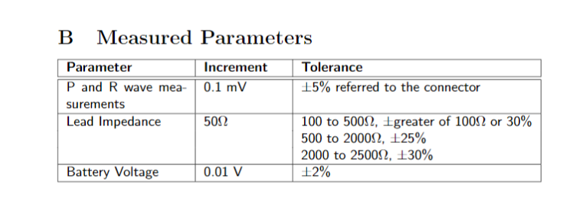

Tabular expressions linking pacing modes with programmable parameters as well as State flow pin variables

|  |  |  |  |  |
| --- | --- | --- | --- | --- |
|  | **Only AOO enabled** | **Only VOO enabled** | **Only AAI enabled** | **Only VVI enabled** |
| **Controlled variable (aka programmable parameter)** |  |  |  |  |
| Lower Rate Limit  p_lowrateInterval | Interval starts at an atrial sensed or paced event. In this case sensed, since there is no pacing.  Starts when ATR_CMP_Detect is HIGH | Interval starts at a ventricular sensed  or paced event.  In this case sensed, since there is no pacing.  Starts when VENT_CMP_Detect is HIGH | Interval starts at an atrial sensed or paced event | Interval starts at a ventricular sensed  or paced event |
| Upper Rate Limit |  |  |  |  |
| Atrial amplitude |  |  |  |  |
| Ventricular amplitude |  |  |  |  |
| Atrial pulse width |  |  |  |  |
| Ventricular pulse width |  |  |  |  |
| Atrial sensitivity |  |  |  |  |
| Ventricular sensitivity |  |  |  |  |
| VRP  p_VRP  ln_sVRP  ln_pVRP  ln_VRP |  | ln_VRP set to high only if one of ln_sVRP or ln_pVrp is high. The s and p VRP are only high when the VRP is active after a spontaneous .ventricular sense/pulse respectively |  | ln_VRP set to high only if one of ln_sVRP or ln_pVrp is high. The s and p VRP are only high when the VRP is active after a spontaneous .ventricular sense/pulse respectively |
| ARP |  |  |  |  |
| PVARP |  |  |  |  |
| Hysteresis  p_hysteresis | Set to false for this part of the project | Set to false for this part of the project | Set to false for this part of the project | Set to false for this part of the project |
| Rate Smoothing |  |  |  |  |

**Likely requirement changes**

In later stages of the project…

**Design decisions that will change in the future**

**Note: Additional testing document will be provided with testing strategies and result**